**Project Design Phase-I Solution Architecture**

|  |  |
| --- | --- |
| Date | 29.09.2022 |
| Team ID | PNT2022TMID41951 |
| Project Name | Project -Smart Farmer-IOT  Enabled smart Farming Application |
| Maximum Marks | 4 Marks |

# Solution Architecture:

Solution architecture is a complex process – with many sub-processes – that bridges the gap between business problems and technology solutions. Its goals are to:

* The different soil parameters (temperature, humidity, light intensity, pH level) are sensed using different sensors and the obtained value is stored in IBM cloud.
* Arduino uno is used as a processing unit which processes the data obtained fromsensors and weather data from weather API.
* Node red is used as a programming tool to wire the hardware, software and APIs.The MQTT protocol is followed for communication.
* All the collected data are provided to the user through a mobile application which was developed using MIT app inventor. The user could make decision through an app, whether to water the crop or not depending upon the sensorvalues.

# SENSORS:

The soil moisture sensor senses the moisture level in the soil. The humidity and temperature sensor gives the humidity and temperature values of the atmosphere which determine whether the crop is suitable for growth. The soil moisture sensor, humidity and temperature sensor continuously monitors the soil and environmental conditions, sends the live data to mobile.

# ARDUINO UNO:

Arduino Uno is the heart of the system. The facts gathered with the aid of the sensors is sent to the Arduino UNO.The gathered information may be displayed in a Arduino IDE.

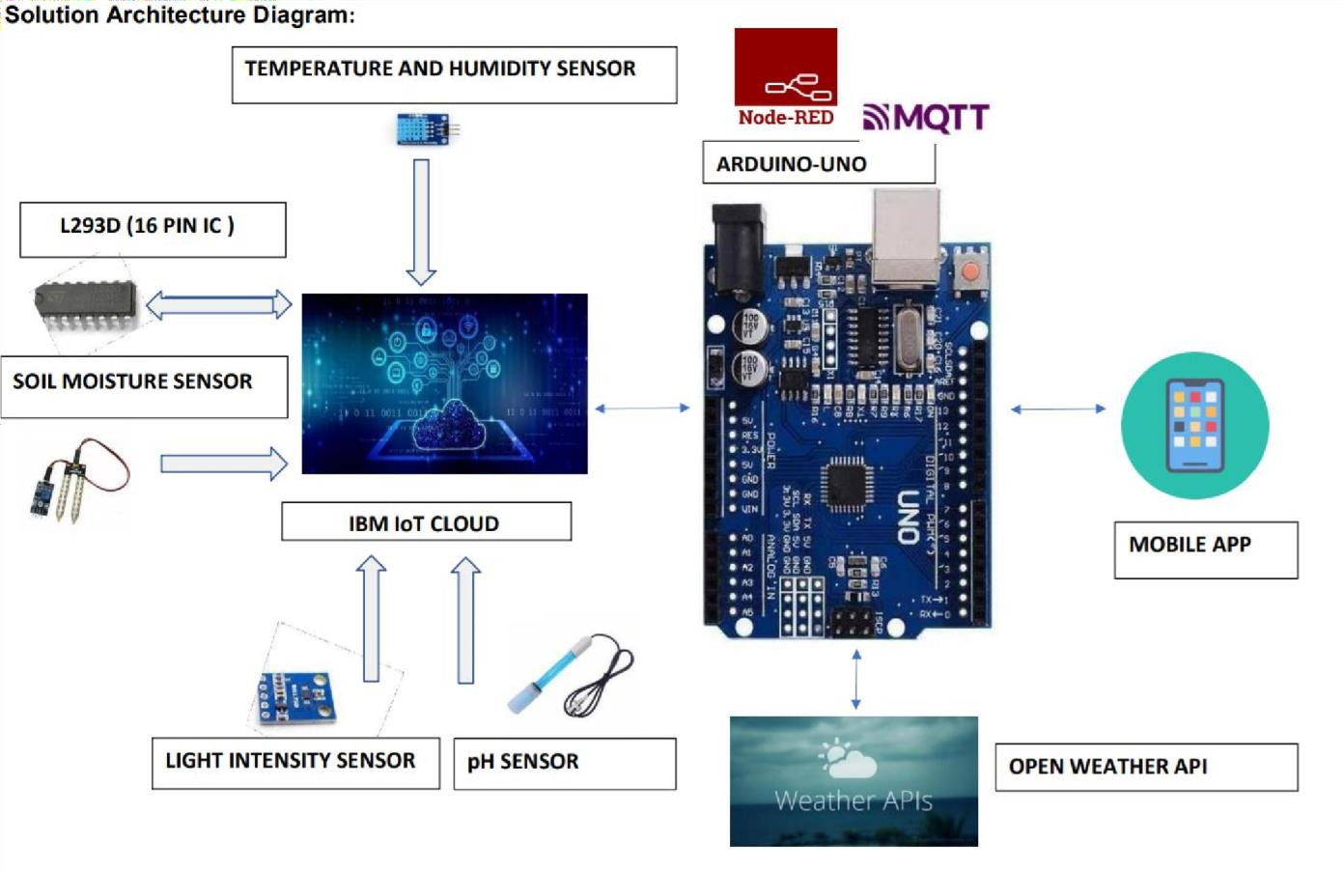

# SOIL MOISTURE SENSOR:

A soil moisture sensor empowers agriculturalists to estimate the water levels without the need to be physically present in the field.

# TEMPERATURE SENSOR:

The temperature sensor senses the surrounding temperature of the farm in different farm conditions.

# HUMIDITY SENSOR:

Humidity sensors are electronic devices that measure and report the moisture and air temperature of the surrounding environment.